Why So Many Denominations?  Imagine a 5-piece cartoon jigsaw puzzle. If we are only shown 1 puzzle piece, it’s easy to be convinced that these are dark storm clouds:  If we are only shown 2 puzzle pieces, it’s easy to be convinced that this is a cartoon tobacco pipe with smoke coming out of the bowl:  If we are only shown 3 puzzle pieces, it’s easy to be convinced that this is a cartoon factory with a smokestack:  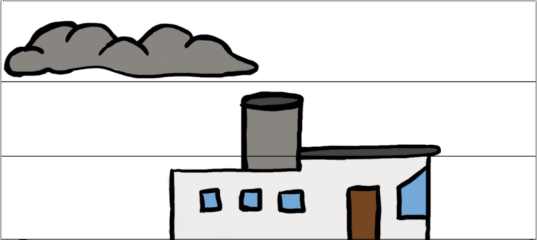  But with all 5 puzzle pieces, it’s clear that the full picture is a cartoon steamboat:  The exact same thing happens with the Bible. It’s easy to be convinced about wrong beliefs if we only look at a few Bible passages. But if we don’t study the full picture for a doctrine, then we might be missing critical information.  To have proper beliefs, we must discern God's guidance and do our best to study all of the puzzle pieces in the Bible for each doctrine.  VividChristianity.com |  |  | Why So Many Denominations?  Imagine a 5-piece cartoon jigsaw puzzle. If we are only shown 1 puzzle piece, it’s easy to be convinced that these are dark storm clouds:  If we are only shown 2 puzzle pieces, it’s easy to be convinced that this is a cartoon tobacco pipe with smoke coming out of the bowl:  If we are only shown 3 puzzle pieces, it’s easy to be convinced that this is a cartoon factory with a smokestack:  But with all 5 puzzle pieces, it’s clear that the full picture is a cartoon steamboat:  The exact same thing happens with the Bible. It’s easy to be convinced about wrong beliefs if we only look at a few Bible passages. But if we don’t study the full picture for a doctrine, then we might be missing critical information.  To have proper beliefs, we must discern God's guidance and do our best to study all of the puzzle pieces in the Bible for each doctrine.  VividChristianity.com

